**An Internship Report**

**OnAn Analysis the Function of Zilla Parishad in Sylhet Division**

**Course Code: PSS-800A**

**Department of Political Studies**

**Submitted To**

|  |  |
| --- | --- |
| **Internal Supervisor** | **External Supervisor** |
| **Syeda Ismat Ara Jahan**  **Assistant Professor**  **Department of Political Studies**  **SUST, Sylhet-3114.** | **Mr. Son Di.p Kumar Sigh**  **Chief Executive Officer (CEO)**  **Zilla Parishad**  **Sylhet.** |

**Submitted by**

**Taslima Akter**

**Reg.No:2018235028**

**Session: 2018-2019**

**4thYear 2ndSemester**

**Department of Political Studies**

**SUST, Sylhet-3114.**



**Shahjalal University of Science and Technology**

**Supervisor’s Certification**

This is to certify that **Taslima Akter,** Registration No.**2018235028,** 4th Year 2nd Semester, Academic Session 2018-19, Department of Political Studies, Shahjalal University of Science and Technology, has done this internship report which is solely intended for the purpose of completing PSS-800A internship program. I accept this as a final internship report.

I wish affluence and property in every aspect of his career.

**Syeda Ismat Ara Jahan**

**Assistant Professor**

**Department of Political Studies**

**Shahjalal University of Science and Technology, Sylhet-3114.**

**Acknowledgement**

My warmth gratitude goes to many people whose affable cooperation and advice helped me a lot bringing my endeavor into realization.

First, I am grateful to my honorable teacher Professor **Dr. Sayed Ashrafur Rahman**, Head, Dept. of Political Studies, Shahjalal University of Science & Technology. I would like to thank our honorable academic Supervisor Professor **Syeda Ismat Ara Jahan,** Department of Political Studies, Shahjalal University of Science and Technology. I am thankful to her continuous support and supervision, suggestions and providing me with valuable information that was very much needed for the completion of this report.

I was placed at Zilla Parishad, Sylhet to accomplish my internship. I have worked there 30 days. I am highly grateful to my co- supervisor **Mr.Sondip Kumar Singh,** chief executive officer, Zilla Parishad, Sylhet for allowing me to complete my internship at Zilla Parishad and providing me all kinds of support. I also like to thanks **Mr.Md Mofijur Rahman, surveyor** for taking me with them to project site and thanks to **Mr. Nilratan** Das to seeing the Dakbanglo since it helped me enhance my practical knowledge. I would also like to express my excessive thanks to all the employees of Zilla Parishad , Sylhet for their constant guidance and support that played a crucial role in the execution of this report as flawless as possible. I extend my gratitude to all my group members for their co-operation.

And finally, I would like to say that I have put my honest endeavor to make the report authentic. I hope this report will represent my knowledge about the topic allotted to me. However, there might be some errors & silly mistakes due to our limited aptitude & time constraint. In this regards, I seek your kind consideration as I am in the process of learning.

**Taslima Akter**

**Reg. No: 2018235028**

**Session: 2018-2019**

**Shahjalal University of Science and Technology, Sylhet-3114.**

**Abstract**

Zilla Parishad is a legacy of the statuary Local Government (LG) system of Indian sub-continental period. It has become an important body of rural local government since 1885. This is a participatory body of the government in the districts of our country. The Zilla Parishad is a first-tier institution of the rural local government system in Bangladesh. It plays an important role in establishing good governance in the country through an effective participation of people from all walks of life. After the independence of Bangladesh, there had been numerous changes made to their structure. Since Union Parishad and Upazilla Parishad are elected bodies so Zilla Parishad was quite unacceptable to the democracy loving Bangladeshi people. So, government initiated and successfully conducted Zilla Parishad election on 26 December, 2016 and 2022 on 17 October to democratize momentous institution which is the highest tier of rural local government. My department, the department of Political Studies introduced internship as a major course (PSS-800A) of 3 credits to let students apply their theoretical knowledge in the practical life.

I was placed at Zilla Parishad, Sylhet to accomplish my internship. I worked under the all departments and prepared my report on the basis of development project implementation during my site visit. Although I faced some problems during my internship but I have overcome these with my studious effort. After all I have enriched my knowledge remaining in touch of Zilla Parishad, Sylhet with enjoyment and interest.

Contents

Chapter: One 6

1. Introduction 6

1.1 Objectives of my Internship 6

1.2 Methodology of my Study 6

1.3 Local Government 7

1.4 Structure of Local Government 8

Chapter: Two 9

2.1 Zilla Parishad 9

2.2 Development of Zilla Parishad 10

2.3 Zilla Parishad act 2000 (Amended) 11

2.4 Zilla Parishad, Sylhet 11

2.5 History of Sylhet Zilla Parishad: 12

2.7 Functions of Zilla Parishad 13

Mandatory Function 2.7.1 13

2.7.2 Optional Functions 14

2.8 Sources of income of Sylhet Zilla Parishad 15

2.9 Expenditure Sector of Sylhet Zilla Parishad 15

Chapter: Three 16

3.1 My Learning Session & Activities 16

Chapter: Four 21

4.1 Reflection on my whole internship 21

Chapter: Five 22

5.1 Limitations of Sylhet Zilla Parishad: 22

5.2 Recommendations 23

5.3 Conclusion 24

Reference 25

# Chapter: One

## 1. Introduction

Zilla Parishad is a service oriented political institution in Bangladesh. This institution serves as a focal institution for preservation of civic rights and their wellbeing providing and implementing civic services and development projects. The Bangle word ‘Parishad’ means council and ‘Zilla Parishad’ translate to district council. It’s one of the important tiers of local government of Bangladesh. It is the legacy of statutory local government (LG) system as introduced in the sub continental period. The district board a local government tier at the district level, was created in 1885.In the course of time, Zilla Parishad has become a people participatory institution in the local governing system of Bangladesh. To establish a good governance in a country’s politics it’s necessary to have a strong local governing body and a democratic, people-oriented service management in the system. Over the years, we are seeing many faulty functioning which is ignoring the fundamentalism of a local government system of a democratic country. As an Internee, I was appointed in Sylhet Zilla Parishad for 30 working days. In my internship days I was attached with many development programs and went to the field level of their projects. As, I worked with the Stuff of the Zilla Parishad so, I was able to find out the problems of Sylhet Zilla Parishad and in this paper I tried to find out my outcomes and also included some possible recommendation to overcome their shortcomings.

1.1 Objectives of my Internship**:**

1. To know the actual activities and functions of Zilla Parishad
2. To know the process of development projects implemented by Zilla Parishad
3. To apply my theoretical knowledge into practical field
4. To enhance my practical and professional skills

## 1.2 Methodology of my Study

This paper is based on information obtained from direct and indirect sources. Direct information was collected through interviews with various people including the chairman of the Zilla Parishad, administrator of the council, chief executive officer, government employees, and contractors. Existing local government laws, regulations, notifications, circulars, guidelines, books, reports, articles and websites were also reviewed for indirect information.

1.3 Local GovernmentLocal Government, in simple words, can be defined as an integral part of central government which is established through locally elected representatives to facilitate welfare activities delegated lawfully. Being a bridge, it connects local people with central government providing services and grants. “It is meant for management of local affairs by locally elected persons. If government’s officers or their hence men are brought to run the local government bodies, there is no sense in relating them as local government bodies” (Kudrat E Elahi Panir vs Bangladesh.1992). It emphasizes on effective participation of local people which can firstly be possible by arrangement of the election in constituting local government.

Local government is the government of difference, responding to different needs, and realizing different aspirations. "There must be a definite power to do things in a different manner from that followed in other areas within the same of state area. If some local body has it in its power to govern in a different manner from other local bodies, there we have Local Government”. (Hemlock 1936 as quoted in Stewart 2000).

In his book “Elements of Politics”, Sedgwick (Sedgwick, 2014) considers local government as government of some sub organs that have special powers to issue regulations or rules within the area which they manage. So Sedgwick connects this government with its legislative character. -(Sedgwick, 2014)

So, it is clear that some vested powers of central government are applied by local government in a region only for the benefit of grass root people.

## 1.4 Structure of Local Government

The structure shows that Zilla Parishad is an important tier of Local Government in Bangladesh and belongs to the rural local government. However, local government includes governmental entity of both elected representatives and selected governing body. The governmental entity which is governed by elected representatives is known as local self government. Since Zilla Parishad is consists of elected representatives. It falls under the local self-government.

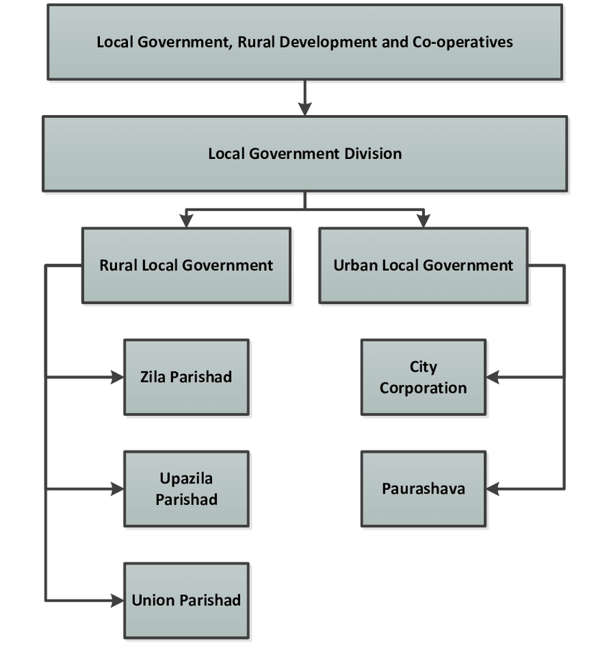

# Chapter: Two

## 

## 2.1 Zilla Parishad

Zilla Parishad is the highest tier of local government system in Bangladesh which is under rural local government. Zilla Parishad was initiated as one of the medium to transfer the authority from central to local level. A study shows the level to transfer of authority from central to local .As the most important tier of local government and to make the tier more effective Zilla Parishad election has been held in 2016.

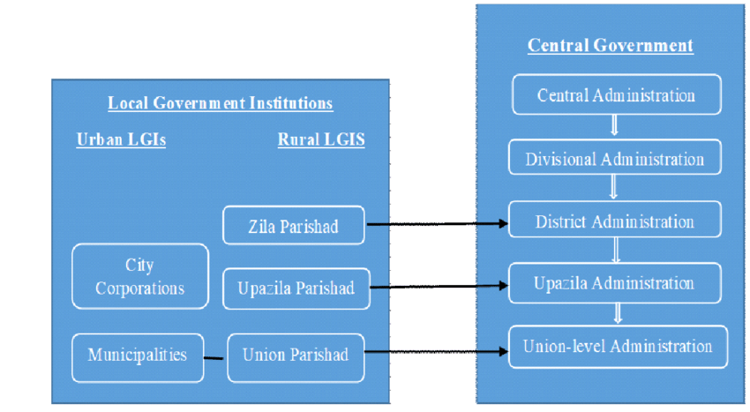

## 2.2 Development of Zilla Parishad

* Sepahay Mutiny in 1857 and Bengal Chowkidari Act in 1870, under this act some villages were included in the union and Chowkidari Panchayat was formed with 5 members.
* District Magistrate appointed all the members for 3 years.
* In 1885 District Board was formed in 16 districts including Dhaka called Local Self Government Act.
* Local boards are formed in each sub-division of each district.
* The members of the district board were elected by the votes of the members of the local board.
* The Chairman was appointed ex officio by the District Magistrate. This clause was in force till 1957
* District Councils were formed in 1959 under the Basic Democracy Order.
* The Deputy Commissioner is ex-officio Chairman.
* District Council members voted by Union Parishad members.
* Vice Chairman is elected from amongst the elected members.
* The 1st election was held in 1963 and the 2nd and last election in 1966.
* The District Board was formed in 1973 by order of the President.
* In 1976 the Local Government Ordinance was renamed as Zila Parishad and in 1988 the Local Government (Zila Parishad) Act was enacted. Later in 1991, the government canceled the formation of Zilla Parishad.
* In 2000, the Zilla Parishad Act 2000 was enacted:
* Later 2016, the Zilla Parishad Act was amended.
* Provisions are made for the constitution of the council consisting of 1 chairman, 15 members and 5 members from reserved seats.
* The Humble Member of Parliament of the concerned district will be the Public Advisor.
* The Zilla Parishad Act vests a Chief Executive Officer of the rank of Deputy Secretary and a Secretary of the rank of Senior Assistant Secretary in the Zillah Parishad.
* On 28 December 2016, elections were held in 61 Zillah Parishad across the country.

## 2.3 Zilla Parishad act 2000 (Amended)

**The Zilla Parishad (Amendment) Act 2022 (Act No.10 of 2022) was last amended by:**

1. 1 chairman, equal number of members of the total Upazilla of the district i.e. 13 members and 05 members of reserved constituencies. (Section-04).
2. The chairman of each Upazilla council, the mayor of the municipality and the representative of the mayor of the city corporation are ex-officio members.(Section -04)
3. The honorable members of Parliament of the respective districts will be advisors. (Section-30).
4. On October 17, 2022, Sylhet Zilla Parishad elections were held for the second time in the country.

## 2.4 Zilla Parishad, Sylhet

Sylhet Zilla Parishad has 13 Upazilas.They are:

Sylhet Sadar, Osmaninogor, Companiganj, Gowainghat, Kanaighat, Zakiganj, Jaintapur, Beani Bazar, Golabganj, Fenchuganj, Bishwanath,Balaganj and Dakshin Surma.

Sylhet Zilla Parishad has a selecting council considering 13 members, 5 reserved members and 1 chairman elected by a total of representatives from 13 wards in Sylhet district.

## 2.5 History of Sylhet Zilla Parishad:

Sylhet district was established on 3 January 1782, and until 1878 it was part of Bengal province. In that year, Sylhet was included in the newly created Assam Province, and it remained as part of Assam up to 1947 (except during the brief break-up of Bengal province in 1905–11). Sylhet district was divided into five subdivisions and the current Sylhet District was known as the North Sylhet subdivision. In 1947, Sylhet became a part of East Pakistan as a result of a referendum (except 3½ thanas of Karimganj subdivision) as part of Chittagong Division. It was subdivided into four districts in 1983–84 with the current Sylhet District being known as North Sylhet. It became a part of Sylhet Division after its formation in 1995. Sylhet has played a vital role in the Bangladeshi economy. Several of Bangladesh's finance ministers have been Members of Parliament from the city of Sylhet.2.6 Organogram of Sylhet Zilla Parishad:

According to the law, the Sylhet Zilla Parishad is composed of one chairman, thirteen members, and five women who are elected by the electorate to fill the reserved seats. Among the government officials, a chief executive officer with the rank of deputy secretary and a secretary with the rank of senior assistant secretary perform all the duties of the Zilla Parishad,Sylhet.

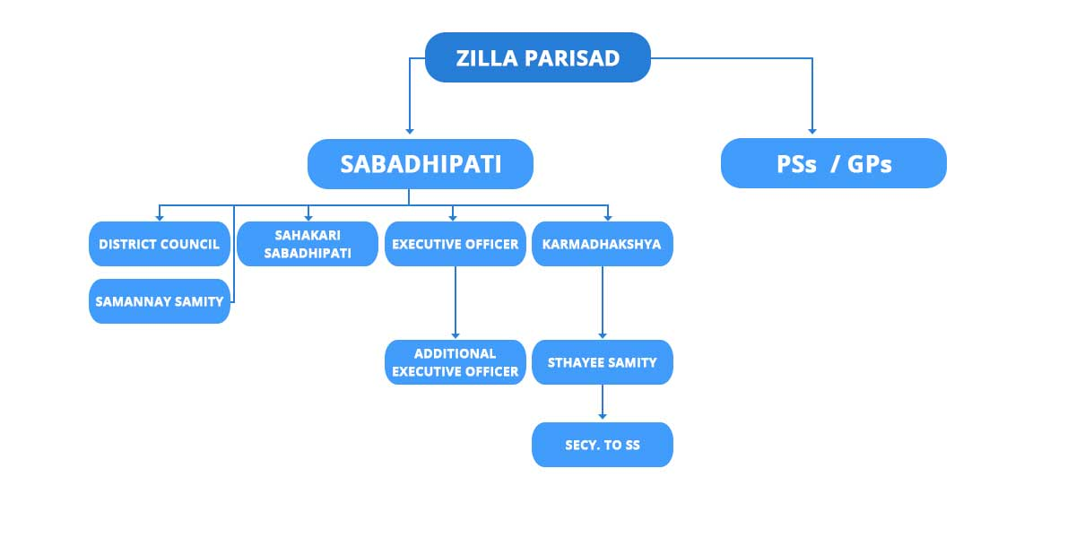

## 2.7 Functions of Zilla Parishad

The Zilla Parishad is obligated by law to carry out two categories of work: mandatory and voluntary. The council will perform the necessary functions with its own funds and will perform the optional functions if it so desires but will be forced to do so if directed by the government.

## Mandatory Function 2.7.1

According to the existing Zilla Parishad Act, the mandatory functions of Zilla Parishad are as follows:

• Review of all development activities in the district.

• Review of the implementation process of the development projects undertaken by Upazilla Parishad and Municipality.• Arranging and maintaining general library for public.• Build and maintenance of such public roads, culver and bridges which are not maintained by the Upazilla Parishad, Municipality or the government.• Tree plantation on roadside and public places and maintaining them.• Arranging and maintaining parks, playgrounds, and open spaces in public areas.• Management and control of ferry which are not under government, Upazilla Parishad or Municipality.• To arrange and maintain inns, dak-bungalows, and restrooms.• Co-operate with other organizations which performing similar operations of the Zilla Parishad.• To provide assistance, co-operation, and encouragement to Upazilla and Municipality.• Perform other activities imposed by the government

•To implement the development plan entrusted to the Zilla Parishad by the government.

## 2.7.2 Optional Functions

Furthermore, the legislation states that the Zilla Parishad shall fulfill a variety of optional tasks in the areas of education, culture, social welfare, economic welfare, public health, and public works. Some of these are given below:

• Establishment and maintenance of schools.• Establishment and maintenance of student hostels.• Arrangement of scholarship programs.• Teachers training.• Planning for education and execution of plan.• Development of sports and culture.• Establishment and maintenance of information center.• Establishment of public hall and community center.• Measures for developing culture.• Providing legal aid for the poor.• Establishment of museum and art gallery.• Organizing volunteers for social services.• Preservation of forests in village.• Collection of raw materials and arrangement of marketing.• Establishment, control and maintenance of markets.

• Welfare activities for woman and backward families.• Development of health-related activities.

• Development of communication system.• Establishment and maintenance of primary health care center.

• Arrangement for the development of religious, moral and matters.• Encouragement for committees on medical assistance.

## 2.8 Sources of income of Sylhet Zilla Parishad

**2.8.1 Own income:**

1. Land transfer fee.
2. Lease of land, pond, ghat.
3. Collection of rent from market, storehouse etc.
4. Transfer fee from housing estate.
5. Grant and renewal of contractor licenses.
6. Dakbanglo for rent.

**2.8.2 Government grants**

## 2.9 Expenditure Sector of Sylhet Zilla Parishad

**2.9.1 Installation cost**

1. Salary allowance
2. Office running expenses
3. Celebration of various national days
4. Land development tax.

**2.9.2 Development expenditure**

1. Implementation and maintenance of development projects,
2. Student scholarships
3. Training cost
4. Distribution of grants.

# Chapter: Three

## 3.1 My Learning Session & Activities

**3.1.1 Monthly Meeting Attendance at Zilla Parishad**

I have learned something new from monthly meeting these are mentioned below.

1. Monthly meeting held in every month a one time. There may be more than one on an emergency basis.
2. Developmental issues were discussed.
3. They already distributed the winter clothes.
4. A project has been taken in Baishtila which cost around 4.5 crores.
5. They decided to give education scholarship to 10 disabled people.
6. Renovation of Ambarkhana Big Bazaar pond.

**3.1.2 Receiving letters, sending and Letter FileReceiving letters**: When the application form related to the Zilla Parishad is sent directly by post from different individuals, offices, ministries, the letter comes to the receiving branch and is sent to the scene file. All the letters that come to the chairman and CEO branch are sent separately to the seen file of the chairman and CEO branch.**Sending Letters:** Implementing the related issues is sent to the ministry office and from the related branch is provided to send all letters.**Letter File:** In order to send letters to any office located in the local or Sylhet Sadar, they have to be sent by entering the peon book. The person in charge of the office where the messenger sends the letter gives signatures that the person in charge of the office has received the letter in the peon book. Not only that, many times the head of the office issues various office orders to complete various tasks. They are signed by the person or assistant peon in charge of the concerned branch and receives the letter

**3.1.3 Budget**There are two types of funds or budget for conducting development activities of Zilla Parishad under development project. These are:

**Own Budget:** The money earns by Parishad from several sources under its control or maintenance is called own fund. Zilla Parishad allot considerable amount of money from its own fund for completing development projects in every fiscal year. The Parishad earns or taken budget from the following sources: • Tax on the transfer of immovable property.• Income from lease of lands.• Income from lease of Ferry Ghats.• Income from the Dak Banglaw.• Income from the rent of auditorium and picnic center.• Income from the housing state and income from the Markets/storehouse/shop.

**Annual Development Program (ADP)**Development planning is considered to be the most important aspects of government’s fiscal policy. ADP came from government as a development project. Approved projects are shown in funding arrangements in the ADP. On the other hand, unapproved projects are also shown in the ADP in its own separated section generally listed without the funding arrangement. In every fiscal year, Government provides a definite amount of money to Zilla Parishad through ADP for development projects and Parishad employees this allotment for the development of districts by giving contractors at 5% less of allotment. This saved 5% get included with own fund.The following pictures show that the annual Income and Expenditure were taken from Own and ADP in 2023-2024 a fiscal year.

**3.1.4 Contractor enrollment and renewal**

First, the contractor has to obtain a trade license. Trade licenses can be obtained from the office of the ward commissioner of the district council, municipality, or City Corporation.Second, Tax Identification Number or TIN must be done and certificate must be there.

Third, Specific forms have to be collected from the district council. The price of the form is Tk 10. In this case, different amounts of fees are applicable according to the type of business. Along with the application form, 3 copies of photographs, rent agreement letter and rent receipt, tax payment receipt along with the tax officer have to apply. In the case of limited companies, copies of Memorandum are to be submitted. Then the original trade license book can be collected on the basis of the necessary verification.There are different types of businesses in vogue.1. A proprietorship/privately owned company

2. Partner organizations3. Joint Capital Company (Private Limited Company / Public Limited Company)

**Renewal of license**Renewal of license is a regular process. An invoicing book for the trade license renewal is included Renewal can be done on a year-wise basis by depositing the required fees in the designated bank.

**3.1.5 Project adoption, resolution and dispatch to the ministry:** In the monthly meeting, the project is divided according to the proportion of the Upazilla and the elected members take up the project. If two-thirds of the approval is received in the monthly meeting, it is sent to the ministry. And when the ministry approves the project, it is accepted and implemented.There are various types of projects: Cultural Projects, Social Welfare Projects, Educational Projects and Technical Projects etc.The project is taken up once a year.

1. **3.1.6 Tender process of approved work**After approval the project Zilla Parishad calls the tender. There are six types of tenders:

* OTM Tender
* OSTETM Tender
* LTM Tender
* RFQ Tender
* DPM Tender
* TSTEM Tender

**Limited Tender Method (LTM):** Zilla Parishad enlisted contractors are eligible to request certain kinds of tenders. PE has the option to call the offer at 5% under or above the project's estimated cost. Whoever calls the tender with the lowest cost wins. If more than one lowest call the winner is selected by lottery.

**Open Tender Method (OTM):** Any PE around the country can call for the tender. The calls can be 10% less or 10% above from the estimated cost of the project. No lottery but four categories is used for selecting the winner.

Request for Tender (RFQ): In ADP the budget the RFQ can be up to 10 lacks for services. But in revenue budget RFQ can be up to 6 lakes for works and up to 3 lakes for services.

Direct purchasing Method (DPM): DPM can be up to tk. 25000 in both ADP and own budget for both work and services. Other types of tender OSTETM and TESTETM are less used on Zilla Parishad. After selecting PE performance security ids given by him, assistant sub engineer visits the site and prepare layout of the project. Then, the Parishad provides working order to the contractor to work on basis of layout. If he changes layouts, he will be personally responsible for the cost since Zilla Parishad will provide definite allotment. However, after working order is given, the projects start to get implemented. After the project is completed, the contractor applies for getting total amount of money for project. Sometimes the contractors apply for getting money after completed 50% of work and paid the bill is called “Running Bill”. The Parishad considers the opinion of sub-assistant engineer. After the bill goes to the assistant engineer, and after his approval the bill goes to the accountant and then go to the assistant engineer and from him to the chairman and CEO. After their approval, it goes to the accountants again and he passes the bill after scrutinizing carefully. After the implantation of project, the performance security is the contractor on the basis of his application after one year of providing total allotment.

**3.1.7 Implementation the work and preparing the bill**After the appointment of the contractor, when 30% of his work is completed, the bill is prepared and the bill is paid. And the bill is paid according to the estimated. The bill is prepared by two way such as 1. Sub- Engineer and 2. Assistant Engineer. There are three types of bills such as project committee, tender and Boucher. **3.1.8** Inspection of the project work

Conducting site visits was an integral part of my internship. I had visited a nearly development project beside the Zilla Parishad office with the surveyor Mr. Mofijur Rahman which cost is 20 lakes and discussed the in and out process of conducting a full development projects by the organization.

**Paying the bill**The bill is paid with the approval of the Chairman and Chief Executive Officer (CEO) of the Zilla Parishad. In the case of retail expenses. There are three types of bills such as project committee, tender and Boucher. more than 25,000 bills are not approved.

**Leasing of Kheyaghat and Land**There are 72 Kheyaghat owned by Zilla Parishad in different Upazilla of Sylhet district. A notification was issued for leasing out the Kheyaghat and land of the Zilla Parishad. The land, or Kheyaghat, is leased for a year in accordance with the prescribed procedure.**Leasing of Pond**Advertisements are given in the newspaper in the case of leasing the pond. Then those who are interested take the auction and lease the pond. The pond is leased out for 3 years.**Training**

Educated unemployed, youth and women are trained by the Zilla Parishad. There are various types of training such as,• Driving Training (every year 100 students).• Computer Training 120 students.

• Sewing Training and freelancing.• Plumbing and fitting Training.

**Maintenance of property**The property of the Zilla Parishad is marked in the record book specified in the District Council. All the properties of Zilla Parishad are number 2. Everything is taken care of by the surveyor based on his work guidelines.**Providing education scholarships**

Who are passed with good result at SSC and HSC such as Science group GPA 5 out of 5 and Humanities group & business group required is GPA 4.50 out of 5. They are selected for the scholarship basis of application.**Property and Market**Housing estate and market are one of the properties owned by the district council. These are given through lease for a period of 99 years.

**Dakbanglo**I had visited the ‘Dakbanglo’ with my team members and our trainer Mr. Nilroton Das. It was my new experience to visit the ‘Dakbanglo’. I have witnessed how Dakbanglo are rented out. And is cared for. The cost of stay in Dakbanglo for government officials is 200 per night and 600 for the general public.

**Donations**Whose are affected the serious crisis of money, owed, serious poor patient, poor individual, institutions and unable to give the marriage of girl. They are selected for getting donation.

# Chapter: Four

## 4.1 Reflection on my whole internship

During my Internship at Zilla Parishad, Sylhet. I worked on multiple tasks and activities both in and field level. I worked in all of departments of zilla Parishad.**Function of Zilla Parishad:** Before my internship, I have only read the functions of Zilla Parishad on books. Now, I have personally experienced the actual functions of Zilla Parishad.

**Attending the Monthly meeting:** I have attended the monthly meeting at Zilla Parishad, Sylhet. Where Chairman, CEO and members got the specific project for the development works at Sylhet Zilla. I have learned how to take a project for the developmental works and maintained the hierarchy.**Visiting to Dakbanglo**: I had visited Dakbanglo in Zilla Parishad, Sylhet. It is a service that offers a rest stop for government employees and the general public. I have learned from that visit how to rent the Dakbanglo and how much time to stay in it.

**Tendering Process:** During the internship, I have known the tendering process of various developing projects and materials for Zilla Parishad.**Administrative Skill:** I have seen the administrative person how to work and maintain the difficult situation of tough condition. I had to perform several official works at the office which helped me to develop my skills at the administrative level during my internship.

**Communication Skill:** Everybody a lot of people come to Zilla Parishad for receiving help and for renting the Ponds, Ferry Ghat and Shop etc. I had to talk with them which helped to develop my communication skills.

# Chapter: Five

## 

## 5.1 Limitations of Sylhet Zilla Parishad:

Zilla Parishad has some limitations. During my internship I have witnessed some limitations which are playing a great role in the proper functioning system of Sylhet Zilla Parishad as a participatory local government body. At first I have mentioned the limitations of Zila Parishad which I have noticed. The limitations of Sylhet Zilla Parishad are given below:

1. Zilla Parishad is an autonomous institution. But it failed to approve a single development project on its own.
2. The Parishad has not yet undergone full digitalization. The authorities complete tasks related to tenders online, but they must manually maintain records in the file, which results in double work for them and excessive workload strain.
3. Engineers are compulsory for the completion of development projects but the Parishad have no Engineers of its own. All of them including Assistant Engineer and Sub Assistant Engineers are on the deputations from LGED.
4. The opinions of beneficiaries are not considered well during the project approval and implementation process.
5. The Parishad doesn’t provide transport facilities to the Engineers for visiting project site.

## 5.2 Recommendations

1. I propose advocating for greater autonomy for Zilla Parishad. This entails lessening reliance on centralized control and giving decision-makers greater authority to successfully address local challenges.
2. The number of employees should be increased to minimize the huge workload.
3. The number of women employees should be increased as an incentive to contribute to women empowerment.
4. The website of ZP needs regular updates so that everyone can get fast information.
5. The Parishad should have its own Engineers.
6. The Parishad should provide transport facilities to the sub-Assistant Engineer for site visit.
7. Development project of Zilla Parishad should be implemented within limited time.
8. They should update their website regularly so that people get all informations about their services.

## 5.3 Conclusion

Sylhet Zilla Parishad is an ancient traditional Local Government Institution. In the modern and developed countries the Local Government is so strong, and they are fully autonomous. But in Bangladesh Local Government institutions are not enjoying sovereignty as an autonomous institution. There are many reasons of not having a proper environment of good governance. However, my internship period at Zilla Parishad, Sylhet was beneficial for me. The friendly environment and coordination of employees allowed me with full opportunities to learn and know about Zilla Parishad more precisely in the internship days. The experience was really beneficiary for me. It added more confidence to my professional approach, built a stronger positive attitude and taught me how to work with public in practical. I have studied various functions of Zilla Parishad and have read many theories on Local Government and my internship helped me to know the actual functions of Zilla Parishad in the practical field and helped to understand the theories of my several courses. During this internship program I have spoken to many people about their observations about policies, development projects or the development projects which benefited them. That helped me to learn public communication and to build a professionalism in myself which will be so helpful for me in future.

## Reference

1. Hasluck, E. L. (1948). Local government in England. Cambridge University Press
2. Sidgwick, H. (2012). The elements of politics. Cambridge University Press
3. www.researchgate.net/figure?local-government-structure-in Bangladesh_fig8_2997173877]
4. Pandey, P. K. (2013), Local Government System in Bangladesh, Lex Locals-Journal of Local self- Government]
5. Organogram of Zilla Parishad.
6. Prospectus, records book of Zilla Parishad, Sylhet
7. http://zpsylhet.gov.bd